

TRAVLR GETAWAYS

CS 465 Project Software Design Document
Version 1.0

Table of Contents

CS 465 Project Software Design Document 1
Table of Contents 2
Document Revision History 2
Instructions 2
Executive Summary 3
Design Constraints 3
System Architecture View 3
Component Diagram 3
Sequence Diagram 4
Class Diagram 4
API Endpoints 4
The User Interface 4

Document Revision History

Version | Date | Author | Comments
1.0 | 02/25/24 | Gabriel | Created sequence diagram and described logic, titled the class diagram, and described class relationships. Explained the RESTful API end points, added the interface

Executive Summary

The selected architecture of the web application includes the MEAN stack which contains MongoDB as the NoSQL database, Express for the server-side, Angular for the front-end framework, and Node.js for the JavaScript runtime environment.

The MEAN stack provides a linkage which allows programmers to use a single programming language(JavaScript) to bind the whole full stack. This provides structured code which quickens the development process. MongoDB ensures the data is managed efficiently while the express and node frameworks manage the back end.

The customer facing side of the application has the users’ thoughts in mind. Angular will use its capabilities to create an interactive user interface. The users will receive a responsive design and the application will include accurate real-time information to be customized to fit their needs.

The Administrator Single-Page Application is solely for administrative users to manage various parts of the system. The design is intuitive and provides administrators with the ability to navigate easily. The data will be customizable which means different layouts will be available to monitor the data. They will also be able to add, delete, and update information to ensure data is up to date.

Only authorized administrators will have access to their privileges based on their authorization levels. Their authentication will grant them access to their privileges.

The Administrator Single-Page Application will have additional features that can be added on in the future.

Design Constraints
The technical constraint in the hardware category may have limitations in processing power and memory. With many users, insufficient processing power and memory will have the system use storage. This will cause the CPU to overclock staggering performance. The budget will need to be spliced so enough processing and memory power is bought. The application may have heavy online traffic, so it is a clever idea to have enough processing power.

The budget constraint consists of cost restrictions, the funds can limit the choices in materials and development tools which will affect the complexity(how efficiently information is processed) of the project. The availability of resources can have a significant impact on the design(look and feel) of the project including the necessary skilled labor and specific equipment. The overall quality and performance of the application is heavily impacted by the budget.

The time constraint can heavily influence the scope of the design of the project. In short, the product needs to be released within a time limit which affects the quality. A consistent schedule is necessary to release accurate up to date representations of the website. One final constraint is cultural differences, each culture will have their unique preferences(these preferences can be generalized).

System Architecture View

Component Diagram

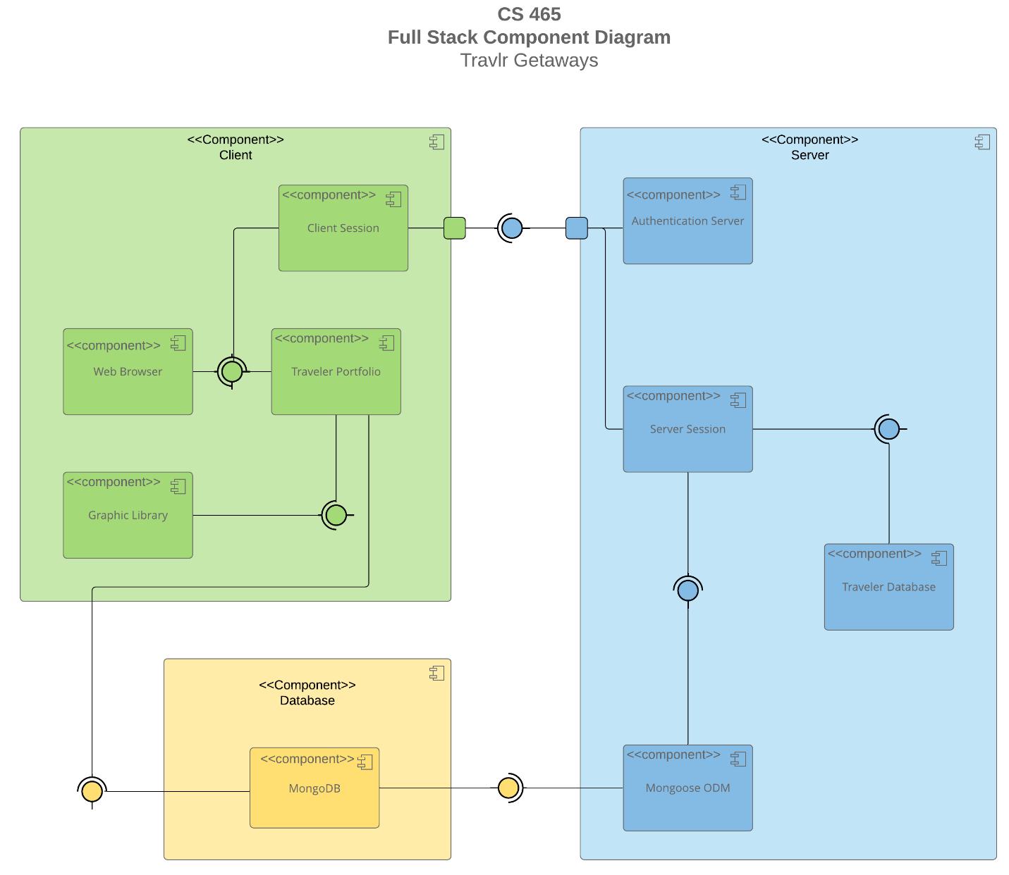

The system architecture has three components: the client, server, and database. The client component holds another four components. The client session, web browser, traveler portfolio, and graphics library. The client session and web browser receive information that the traveler portfolio supplies. The client session has a node which lets it receive information from the authentication server in the server component. The graphics library receives data. The client component/traveler portfolio receives information from the database and server component. The database component supplies information from the MongoDB component.

The server component is made up of four inner components: the authentication server, a server session, traveler database and mongoose for object data modeling. The authentication server connects, and supplies information passed a node to the client session. The server session receives information from the mongoose ODM and ODM receives information from the MongoDB component. The traveler database receives information.

Sequence Diagram
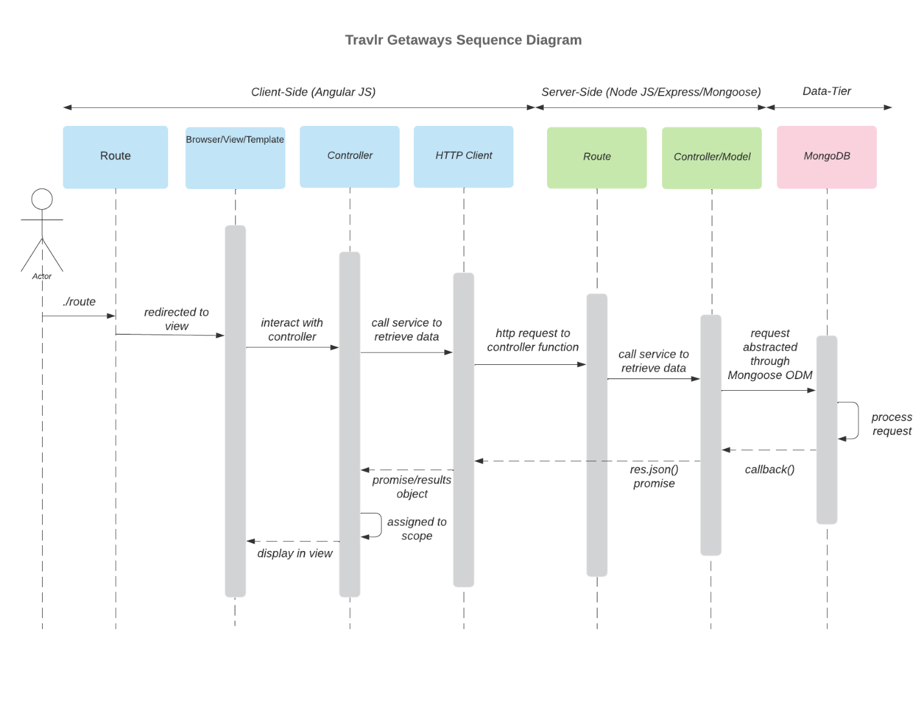
When the client first enters the URL, the request must first go through the router then proceeds to the Browser/View/Template. Afterwards, the client interacts with the UI which will prompt the controller. The controller assigns the scope and responds to the Browser, meanwhile interacts with the HTTP client to retrieve data. The HTTP client sends a request to the controller function which the Route on the server-side takes care of. The route forwards to the controller/model on the server-side to retrieve data and load the model. The controller holds the application logic to connect to the MongoDB, the database processes the request. The database sends a callback to the controller/model which then sends a promise if the process completed or there were issues to the HTTP client. Then the HTTP client forwards the promise to the controller which then assigns the scope. And lastly, the controller sends the logic so the Browser can render the view.

For the trip process, the user first needs to sign-in with the email and password registered. If the database and controller validate the credentials, then user is sent to a new Browser where he can add or edit a trip. The user can add a trip by clicking the add button and this will load the add trip page. The user then needs to fill in the textboxes with data. Then the controller will send the HTTP client a request to connect to the server-side. So, the trip gets added in to the MongoDB, of course, once the route and controller/model are processed. The edit-trip follows a similar sense, but the browser loads a different web page. And both send callbacks and promises back to the controller/model, HTTP client and controller.

For admin interaction, the user will need to interact with the browser to do any managerial tasks. The user interacts with Browser to initiate the controller to access the server-side for administration purposes. The server-side will need to authenticate and confirm the administrator’s credentials and request before performing any tasks. The model will then interact with the controller to change( adding or deleting a user). Then it will send a result back to the client indicating success and update the MongoDB.

Class Diagram

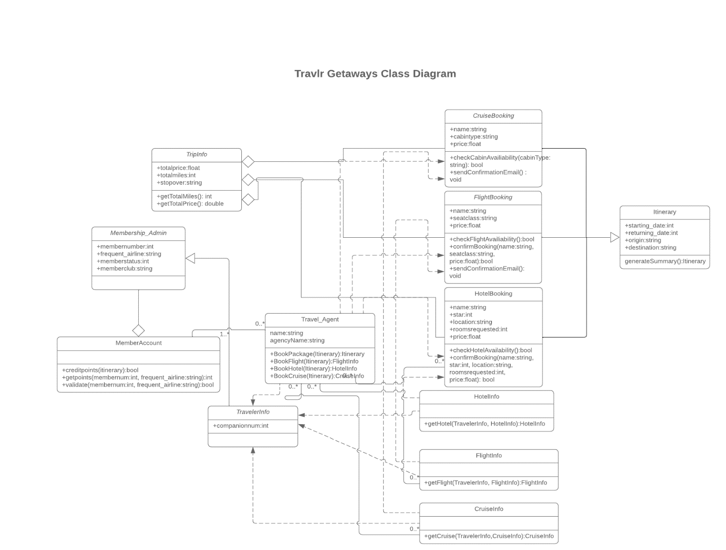
The Travlr Getaways JavaScript class diagram consists of twelve classes. Beginning with the Travel_Agent class(this class has a dependent relation with Traveler Info), this class will consist of the travel agents and agencies name. This class will have methods that sends an itinerary to access the Hotel Info, Cruise Info, Flight Info classes. They have zero too many associations with Travel_agent. And will be used when the Travel_Agent requests access to any itinerary. And lastly, these classes have a dependent relationship with their booking classes and Traveler Info class.

In addition, Cruise Booking, Flight Booking, Hotel Booking have a dependency relationship with Travel_agent. They all have a name and price variable. Specifically, the Cruise Booking and Flight Booking classes have a cabin type and seat-class variable, respectfully. Both have methods to check their availability and send a confirmation e-mail once confirmed. Uniquely, Hotel Booking has three additional variables which are the stars, location, and rooms requested. These classes are inherited from the itinerary class which has the starting date, returning date, origin, and destination data and the ability to generate a report. One last connection for the Booking classes and that is their aggregation of the Trip Info class. This class contains the total price, total miles, and stopover data and the methods to obtain the total miles and price.

The Traveler Info class only has a companion num variable that will be used to keep track of how many people board the flight. This class is inherited from the Membership Admin which has the data member Number, frequent airline, member Status, member Club. This data is passed to the member Account class which has the credit-points, get-points, and validate methods. This class is aggregated by the Membership Admin class.

There is an association between the Travel Agent and Member Account class, they have one too many and zero too many relationships.

API Endpoints

Method | Purpose | URL | Notes
GET/POST | Retrieves a list of trips | <app_api/trips/> | Returns all active trips
GET/POST | Retrieves a single trip | <app_api/trips/:tripCode> | Returns single trip instance, identified by the tripcode passed on the request URL
POST | Registers a new user | <app_api/register/> | Registers the new user into the MongoDB
POST | Logins the user | <app_api/login/> | Validates the credentials of the user
DELETE | Deletes a trip from database | <app_api/trips/:tripCode | Deletes the trip by tripcode from the tripListing

The User Interface

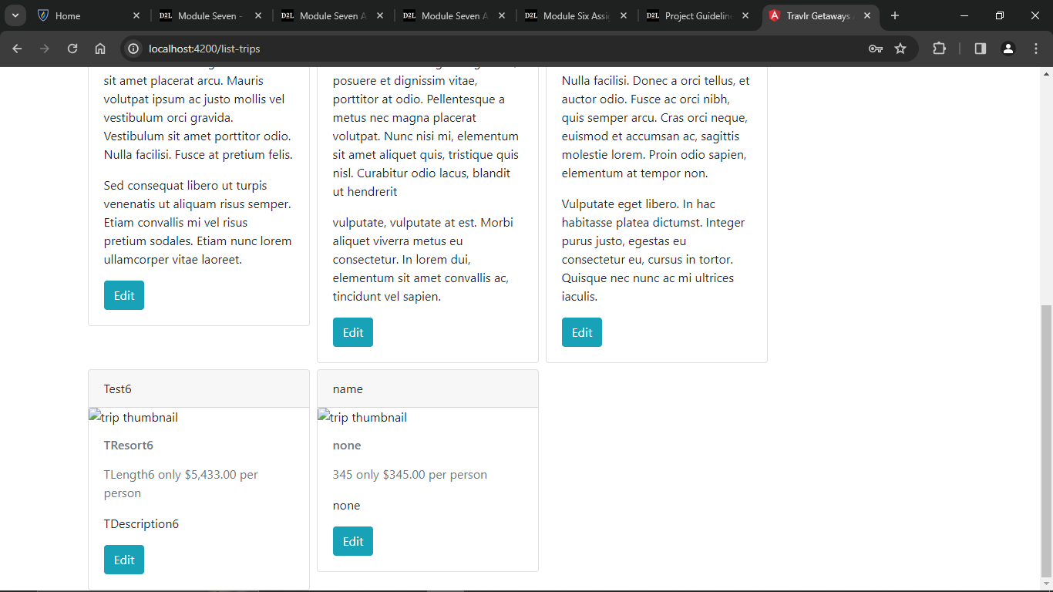

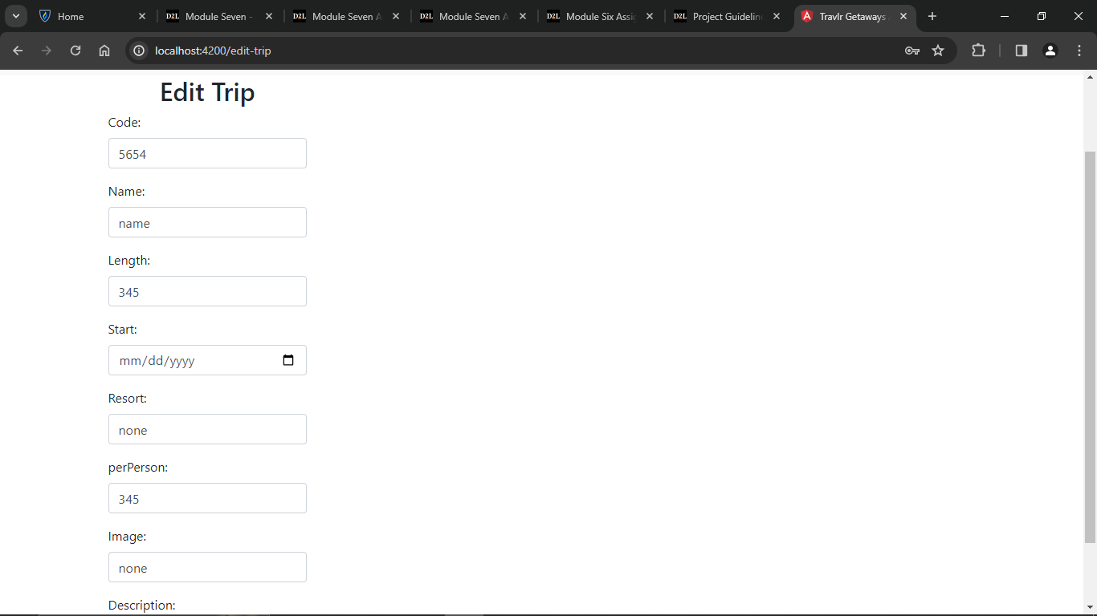

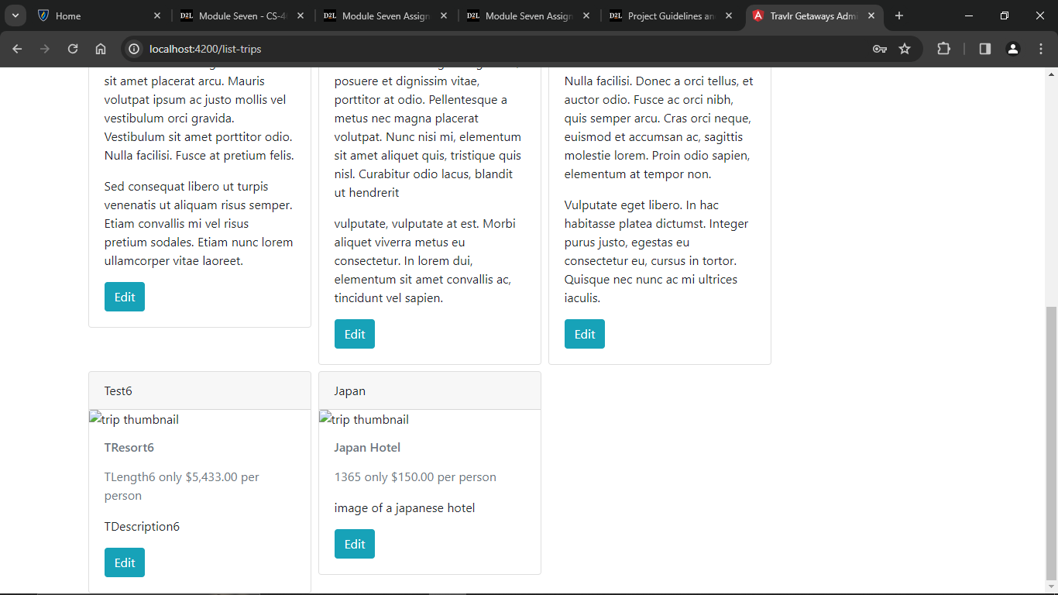

Angular is used to create Single Page applications and the project structure where the code resides is src. The src folder is where the app and assets are contained. The angular. Json file is where the build and serve code resides. The package json file is where the dependencies are. In short, the angular project structure emphasizes the separation of concerns. The difference between Angular and Express lies in the latter containing server-side code, for example, the model, which contains a data structure for the database. As well as the application logic(controllers) and rendering the view for the web page.

The advantages of a Single Page Application are improved user experience, fast performance, and is easy to maintain. An efficient viewing of different sections without rendering a new webpage. SPA reduces the strain on the server by only exchanging data instead of whole HTML pages. The codebase is separated into modules, components, and services which makes the code easy to maintain.

One major disadvantage SPA has is the knowledge required to initiate it. A developer must have knowledge of frameworks, libraries and programming languages like JavaScript and TypeScript. SPA provides real time updates meaning the user does not need to refresh the webpage once new content is uploaded.

Unit testing the SPA by providing fake data to verify if the code validates and issues error responses when needed. Integration testing between the SPA and endpoints would require sending the request to the API with the data(data that is expected). And it’s best to practice security testing like input validation and check for any malicious code injections.

The SPA needs to process data accurately consistently and accurately as well as implement proper error handling. In addition, the API needs to respond in a timely manner. These are errors I will most likely run into.

I have three questions about future SPA builds. First off, how do I improve search engine optimization since SPA is known for its SEO challenges? How will I implement proper authentication and authorization mechanism that also assign role-based access control? And finally, improving the rendering view time and reducing initial load times, how can I reach maximum optimization?

